**2007 SCCA/HRC HISTORIC RALLY**

On October 5th and 6th, the SCCA in conjunction with Historic Race Circuits 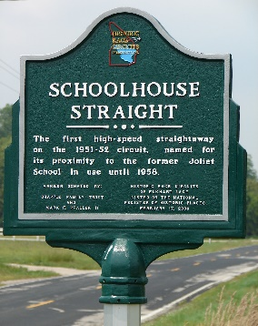of Elkhart Lake staged the Elkhart Lake Historic Rally in and around the Village of Elkhart Lake, Wisconsin. The event celebrated the 55th anniversary of the SCCA sponsored Monte Carlo style rallies held in conjunction with the Elkhart Lake open road sports car races in 1951 and 1952.

**1951-52 Monte Carlo Rally**

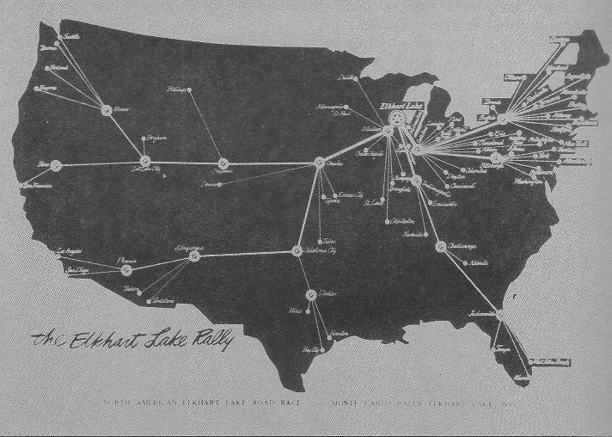The 1951 and 1952 Monte Carlo styled rallies were modeled after the famous European Monte Carlo rallies. Rally teams began the rally at any of sixty-five cities spread all across the United States. Teams were allowed to select their own average speed with the objective of reaching Elkhart Lake on the Saturday of the race weekend. Each team was awarded “starting points” based on their distance from Elkhart Lake. As the teams progressed from check point to check point, points were deducted based on early or late arrival times. Thus, teams traveling the greatest distance had more leeway for error than teams traveling shorter distances.

**The 1951-52 Monte Carlo Rally Map with starting locations and check points.**

Check points along the route were major cities within SCCA Regions. As the rally teams progressed across the Country, more and more teams came together at each check point were the local Regions hosted receptions. The result was one of the largest moving parties in rally history.

**The 2007 Elkhart Lake Historic Rally**

Unlike the original Monte Carlo style rallies, the 2007 rally was run in a time-speed-distance (TSD) format but the emphasis was on the pure joy of owning, displaying and driving their cars as were the original rallies. The Rally was an SCCA National Points Rally with teams competing in three SCCA classes Equipped, Limited and Stock, based on the sophistication of the navigator’s equipment, plus… a special class for Vintage Cars from 1960 and prior. Entrants came from Texas, Oklahoma, Kansas, Iowa, Indiana, Illinois, Minnesota as well as Wisconsin. Fall colors were near peak and the weather was unseasonably warm for October making conditions nearly perfect for the event.

Participants and SCCA workers arrived in Elkhart Lake on Friday the 5th and had the option of participating in the forty-five minute Drive America “Touring” Session on the Road America race circuit. The Drive America event was a benefit for the March of Dimes sponsored by the SCCA Milwaukee 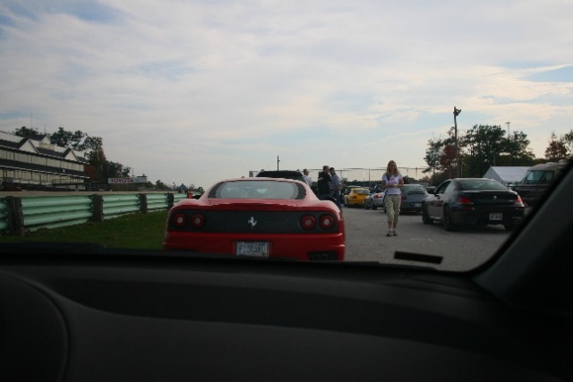Region.

**The 2001 Ferrari 360 Modena of Loren Ziglin and Kyle Rhode follow the 1950 Saab 92 of Marty Adams and Tim Winkler over the Kohler Bridge.**

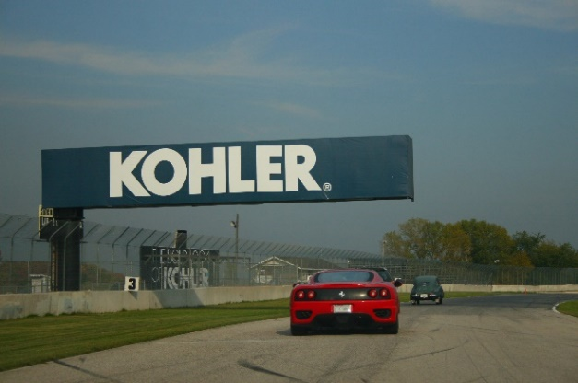

**Rallye participants lined up in the marshalling lane at Road America for the start of the Drive America benefit touring session.**

Following the Drive America track event, rally participants adjourned to the historic race bar at Siebkens Resort (The Last Open Bar) for registration and check-in. Capping off the evening the rally teams joined the Drive America participants for a buffet dinner in the Siebkens Resort dining room. The dinner was hosted by the Milwaukee Region.

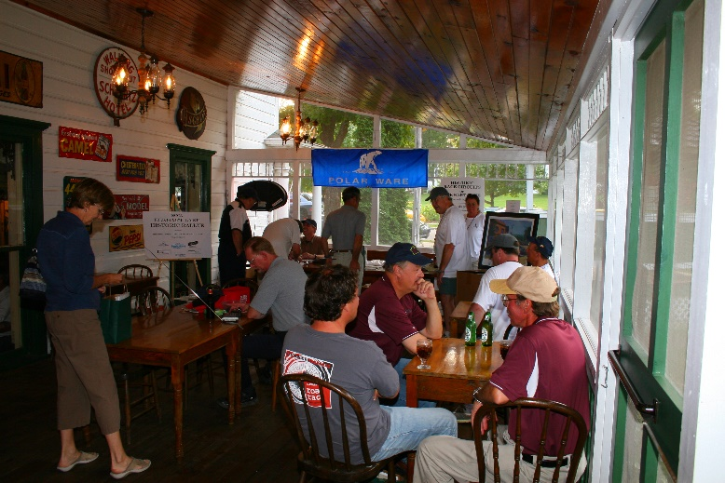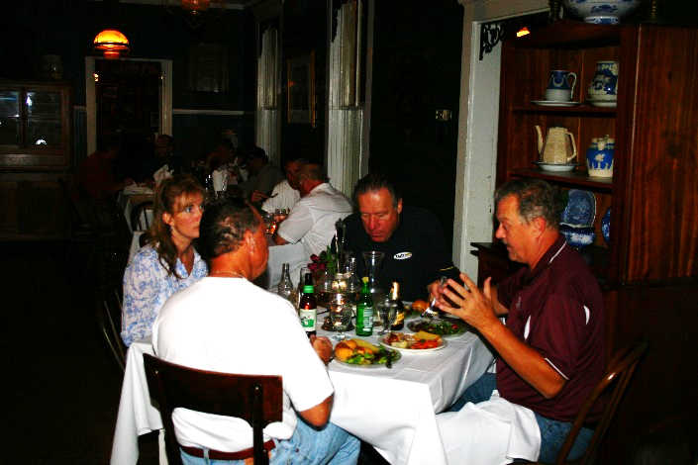

**Tim Craft, SCCA Rally Coordinator, checks in teams in the Siebkens Historic Race Bar porch.**

**Participants in the Siebkens dining room for the Drive America buffet dinner.**

**Participants in the Siebkens dining room for the Drive America buffet dinner.**

Saturday morning at 8 AM the SCCA offered an optional thirty minute “Rally School” covering the basics of the TSD rally format. The majority of the rally teams had limited rally experience and the school was filled to overflowing. Tim Craft, SCCA National Rally Coordinator who conducted the school, did an outstanding job and participants left with rising confidence.

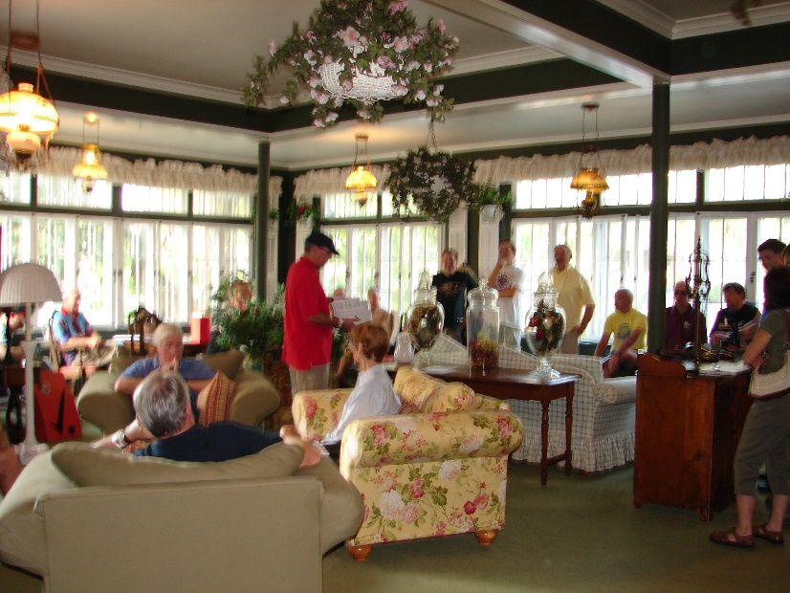

**Tim Craft, SCCA National Rally Coordinator (red shirt and dark cap), conducts the Rally School held in the Siebkens Resort Lounge.**

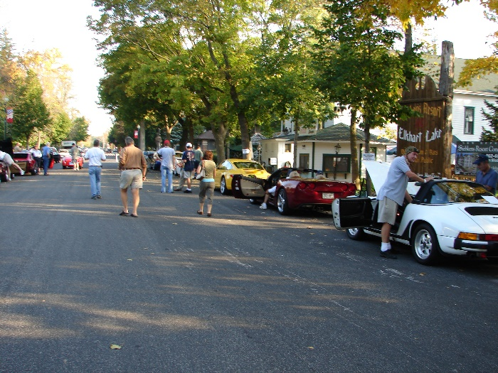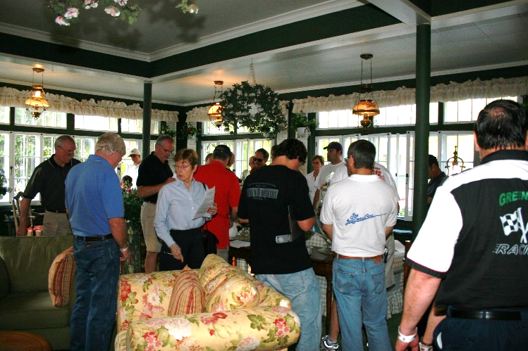Following the Rally School, route instructions were distributed for the first time. With instructions in hand, most rally teams settled in to deciphering the instruction while other more experienced teams took in the myriad of cars lined up for the rally start.

**Cars lined up on Lake Street prior to the rally start just north of the “Hard Left” Historic Marker.**

**Rally participants pouring over the route instructions prior to the start of the Rally.**

Equipment varied by class from the Stock Class all the way up to the (fully) Equipped Class.

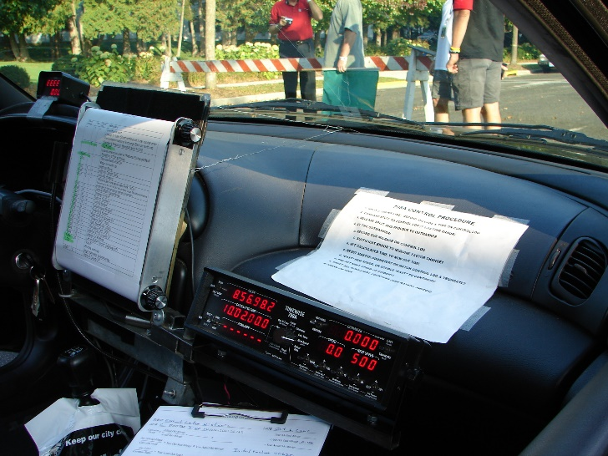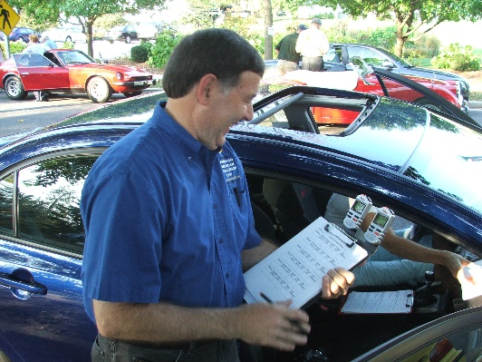

**Stock class rally teams competed with simple clip board and stop watches reminiscent of the “50’s” but with modern calculators.**

**(Fully) Equipped class rally teams used the latest computerized digital technology that calculated down to hundredths of a second.**

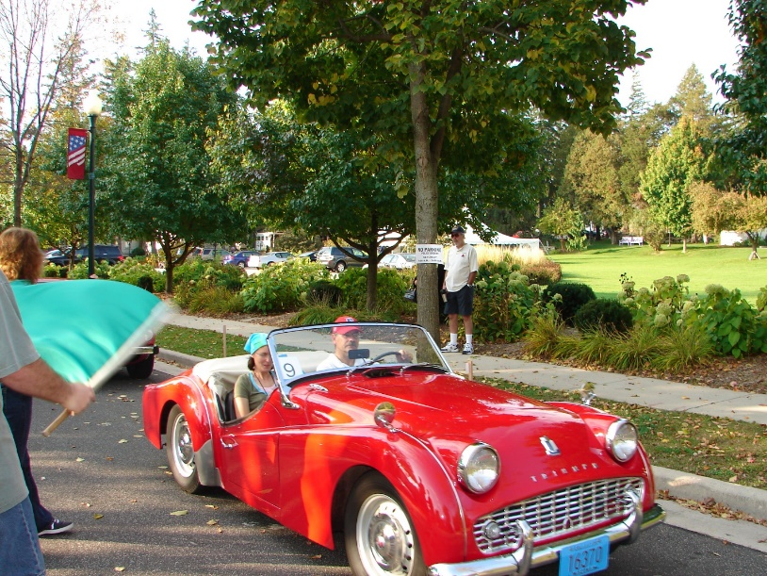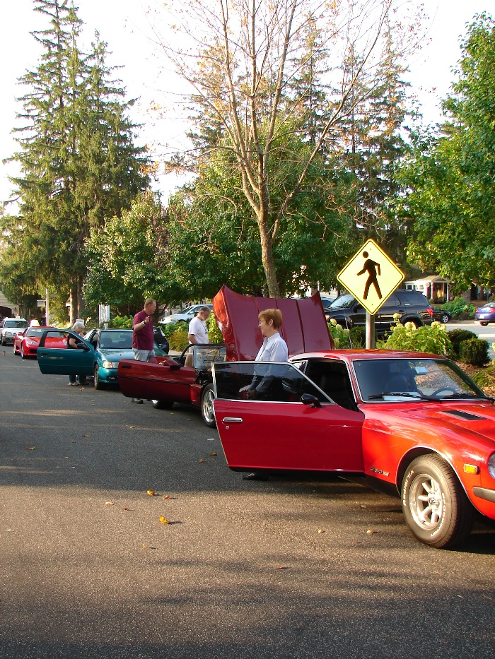Promptly at 9 AM the first cars were called to the ceremonial starting line at Lake Street and Elm, the original 1951 Start/Finish Line before it was changed to the Feed Mill location. Each car was recorded and individually green flagged onto the rally route to begin the rally.

**David and Sue Kettler from Sheboygan Falls, WI in their immaculate Triumph TR3 take the green starters flag at the ceremonial start of the rally.**

**Cars lined up on Lake Street waiting for the 9:00AM start time. The 1978 Datsun 280Z of David and Julie Martin from Henryetta, OK near the front**

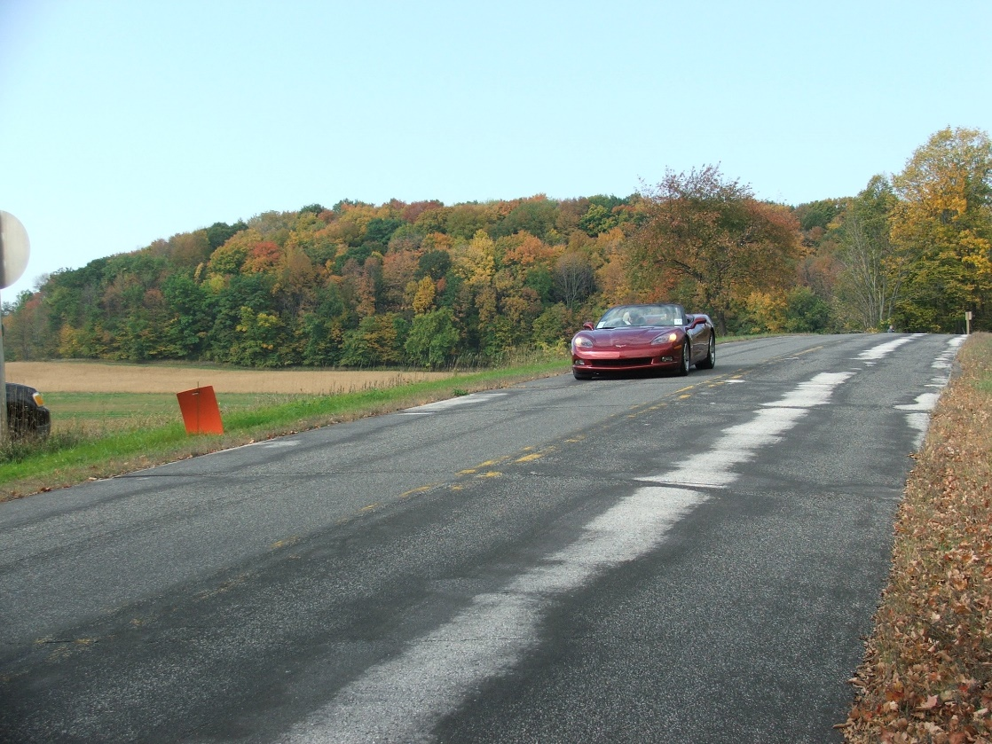After leaving the starting line, teams toured the Historic Elkhart Lake Open Road Race Circuits to warm up their tires and calibrate odometers. From there the teams headed north thru rolling farm lands and past lakes and rivers, in the process passing three check points. Only one team failed to hit all the morning session check points and segment scores were amazingly close to target times.

**Jim and Kris Rohde from Eden Prairie, MN in their 1986 Corvette approaching the first check point.**

At the end of the morning session, rally teams and worker were treated to a New York Style Deli Buffet on the Osthoff Resort’s Lake View Patio overlooking Elkhart Lake. It was warm, the view was stunning and the food was first class.

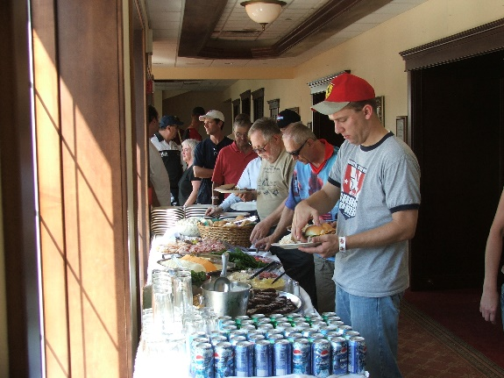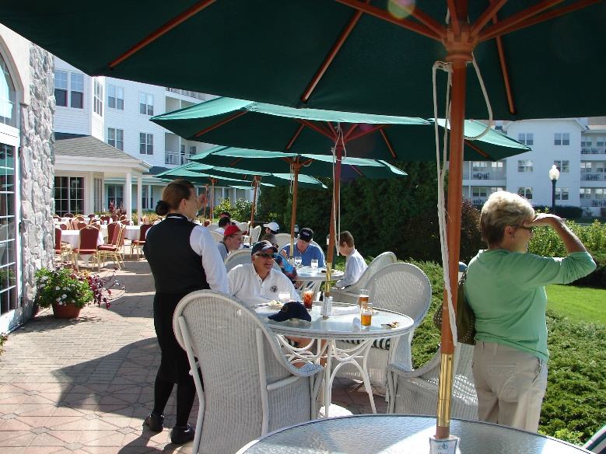

**The luncheon buffet at the Osthoff Resort.**

**Dining on the Osthoff Lake View Patio.**

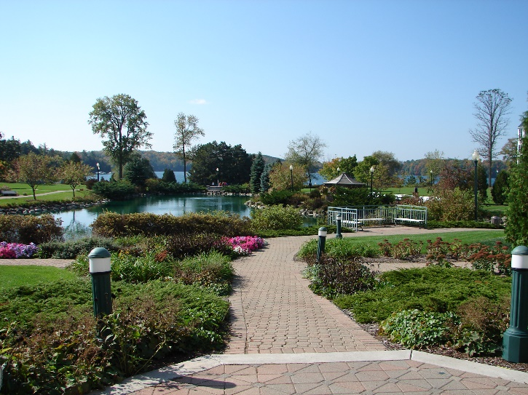

**The view from the Patio looking west over Elkhart Lake.**

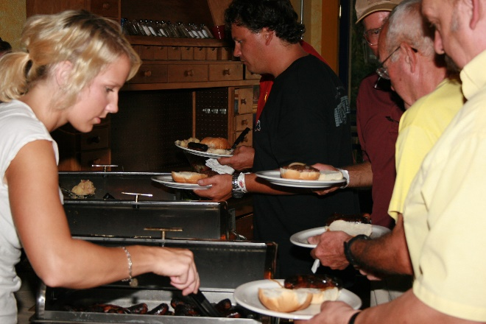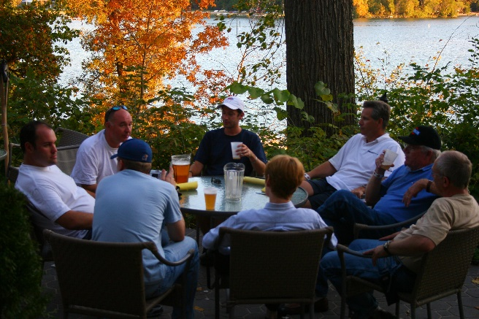Having warmed up in the morning session, rally teams did some serious rallying in the longer afternoon session returning to the finish on Lake Street in Elkhart Lake shortly after 5 PM. While scoring coordinator Brian Berg totaled the rally scores and determined class winners, rally teams and workers adjourned to the Back-Porch Bistro at the Victorian Village Resort for refreshments, to compare notes and to swap rally stories. As the sun set over Elkhart Lake, the gala “Wisconsin Beer and Brat” dinner was rolled out featuring traditional Wisconsin bratwurst with all the trimmings.

**The traditional “Wisconsin Beer and Brat” buffet.**

**Rally participant relax in the Back-Porch Bistro.**

The much-anticipated award presentations began immediately after the dinner. Tim Craft, National Rally Coordinator for the SCCA, hosted the presentations. The “Badger Mutual” Trophy for the best time in the Equipped class and first overall went to experienced rally competitors Mike Thompson and Fred Rosevear in a 1993 Subaru Legacy. The “Polarware” Trophy for the Limited class winners went to Derrick Carpenter and Rich Bireta from Topeka, Kansas who competed in a 1998 Honda CR-V. The “Sargento” Trophy for the best score in the Stock class went to Holly and Tim Kemmis, new SCCA members in their first SCCA rally, driving a 2007 Honda Civic Si.

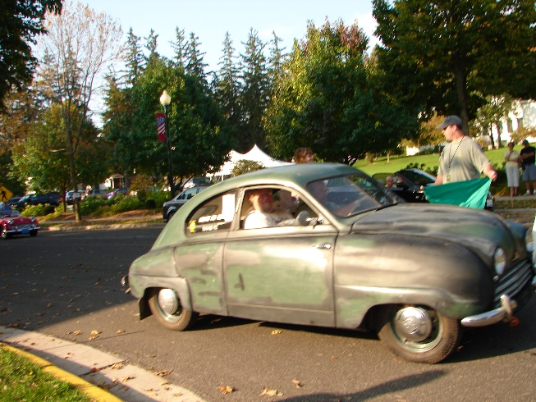

The “Armsup Motorsports” Trophy for the Vintage class went to Marty Adams and Tim Winker who rallied in a 1950 Saab 92 that had participated in the original Elkhart Lake Monte Carlo Rallies of 1951 and 1952 and still wore the dash plaque presented at those events.

**The Vintage Trophy winning 1950 Saab 92.**

All of the rally teams appeared to be having a great time but the Chairman’s Award for the team who seemed to have the most fun went to the team of Kevin Rogers and David Johnson in Kevin’s “ground up” restored 1960 Austin Healey 3000 MK1.

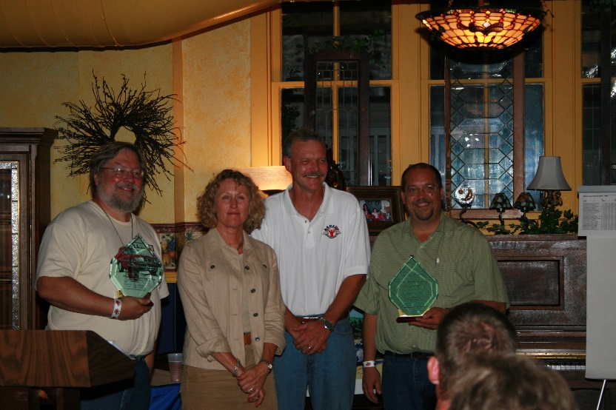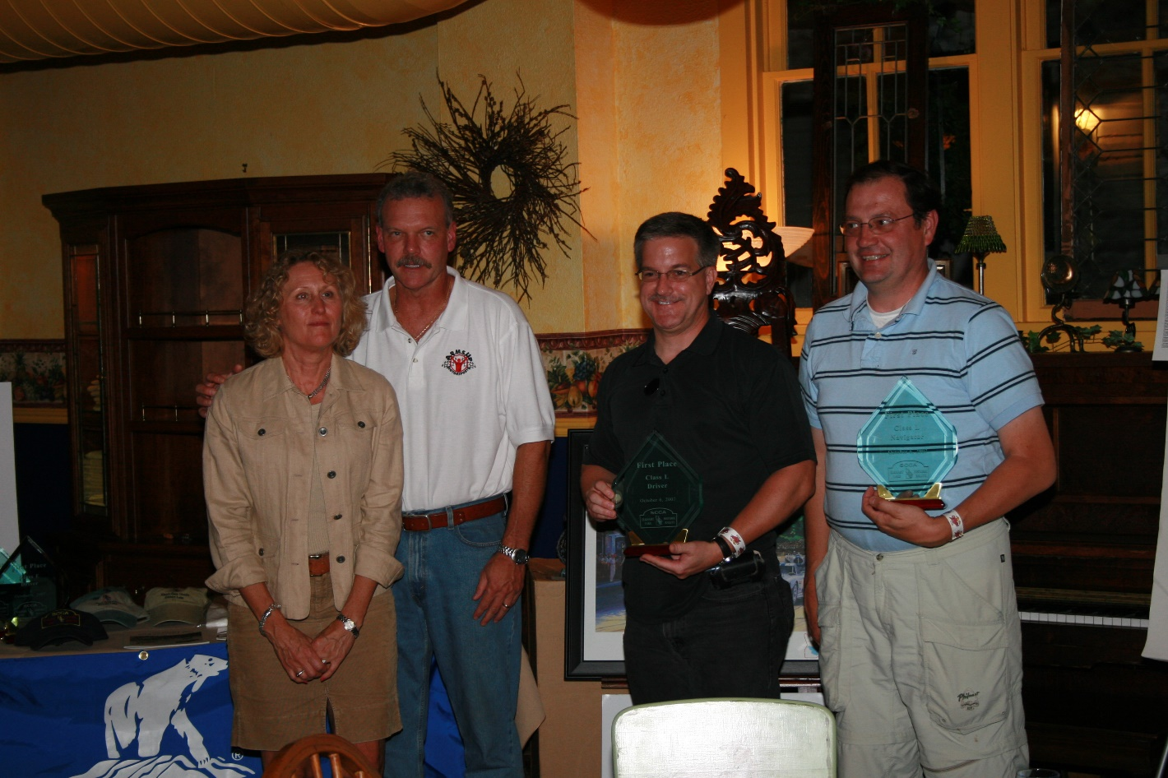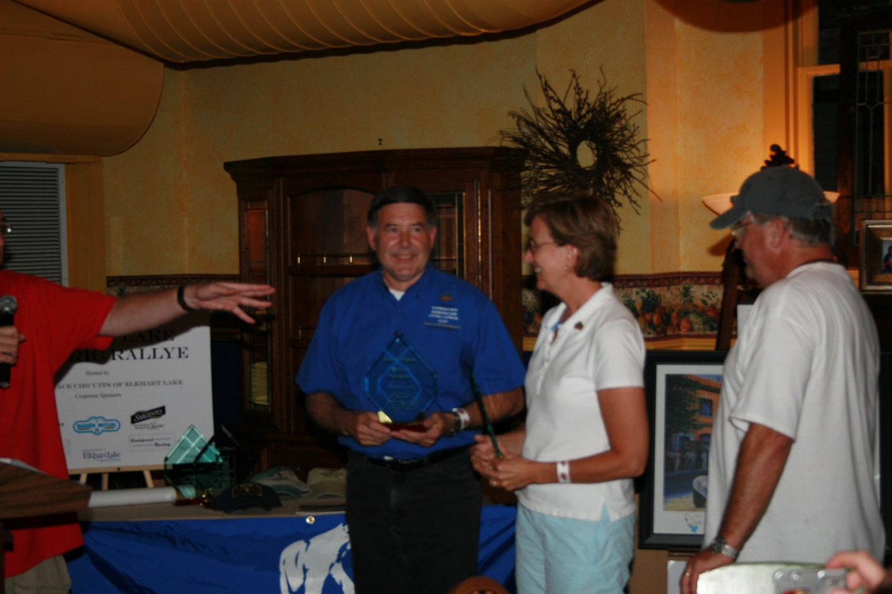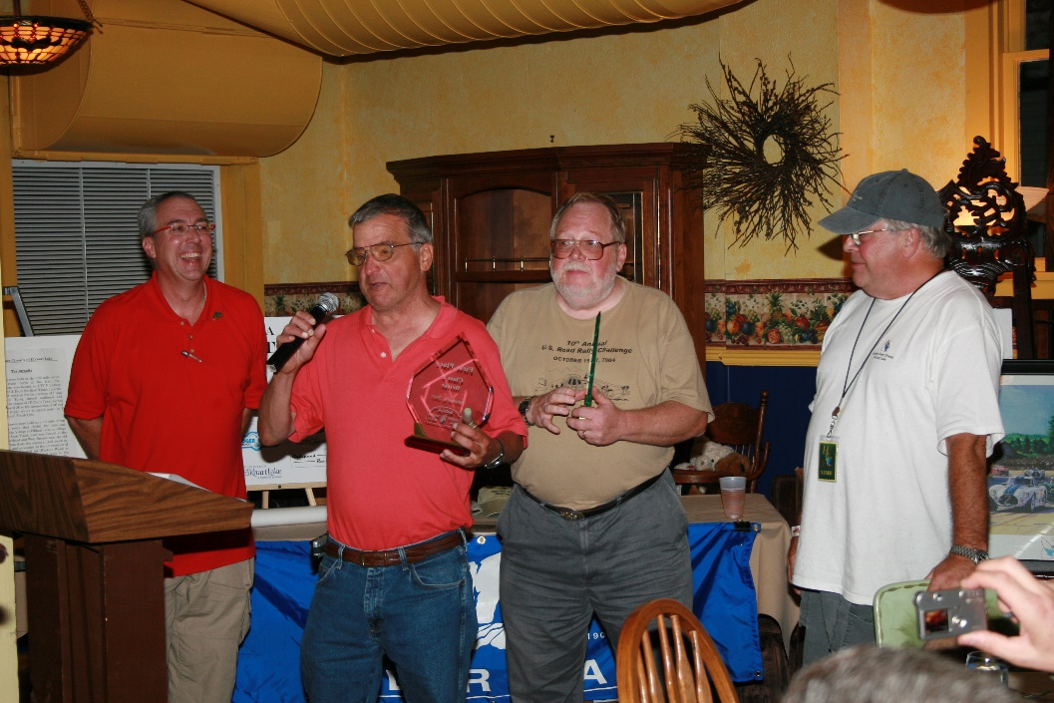

**Derrick Carpenter (right) and Rich Bireta (Left) winners of the Limited Class receive their trophies.**

**Marty Adams (right) and Tim Winker (left) winners of the coveted Vintage Class Trophy presented by Walter and Mary Jo Vollrath (center) for Armsup Motorsports**.

s

**New SCCA members Holly and Tim Kemmis were winners of the Stock Class in their very first SCCA rally**.

**Mike Thomson (center) and Fred Rosevear (right) accept the Trophy for the Equipped Class and First Overall from SCCA Rally Coordinator, Tim Craft.**

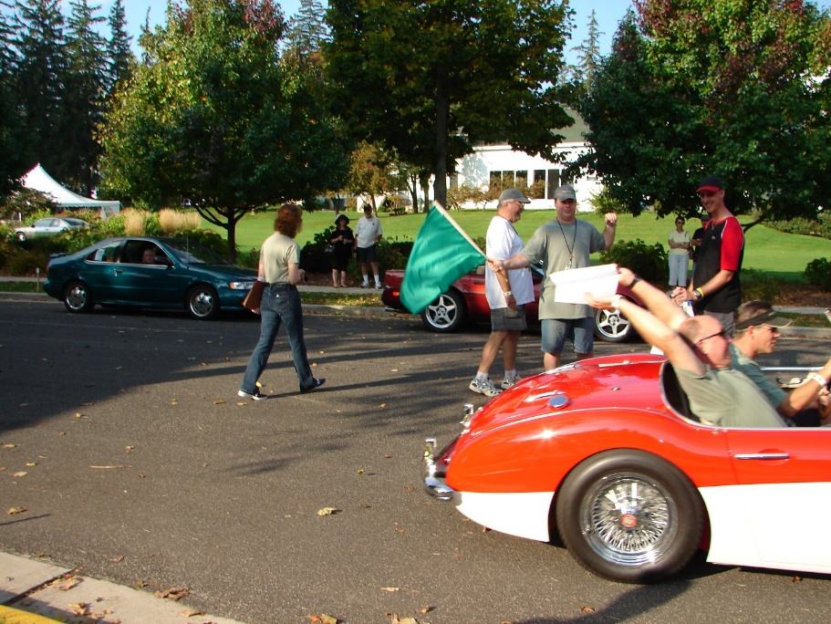

**Kevin Rogers and Dave Johnson who received the Chairman’s Award for the team who seemed to have the most fun, get away from the starting line a little too fast for our ace photographer.**

The rally participants, the SCCA, and the many workers who made the event function so smoothly all agreed that the rally had been a huge success and participants committed to return for future events and bring their friends as well.

Sponsorship for the inaugural Elkhart Lake Historic Rallye was provided by the Elkhart Lake Tourism Commission and the following local businesses;

**AWARD SPONSORS**

|  |  |
| --- | --- |
| **Armsup Motorsports & Godspeed Racing**  P.O. Box 312 Elkhart Lake, WI 53020 920-467-9779 [www.armsupmotorsports.com](http://www.armsupmotorsports.com/)  Sponsors of  **The HRC Vintage Trophy** | Sargento  **Sargento Foods, Inc.**  1 Persnickety Place  Plymouth, WI 53073 800-243-3737  [www.sargentocheese.com](http://www.sargentocheese.com/)  Sponsor of **The SCCA Stock Class Trophy** |
|  |  |
| **Badger Mutual Insurance Co**.  1635 West National Ave.  Milwaukee, WI 53204  800-837-7833  [www.badgermutual.com](http://www.badgermutual.com/)  Sponsor of  **The SCCA Equipped Class Trophy** | **The Polarware Company**  2806 N. 15th Street  Sheboygan, WI 53083  800-237-3655  [www.polarware.com](http://www.polarware.com/)  Sponsor of  **The SCCA Limited Class Trophy** |
|  |  |

*Note: Replace the photo on the Previous Events Main Page with this photo*….

