2006 DEDICATION CEREMONY
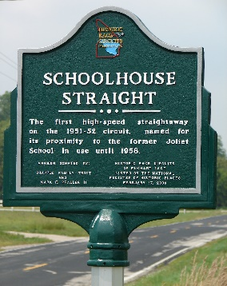
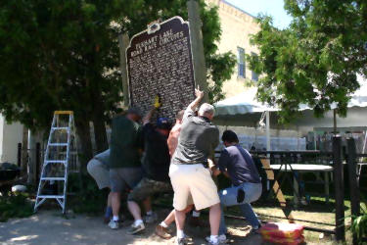
On February 17, 2006 the Historic Race Circuits were recorded on the National Register of Historic Places by the Department of the Interior making the circuit eligible for placement of a Wisconsin State Historical Marker on the site. After carefully researching the history of the named location around the circuits, HRC sponsored a campaign to raise funds for the placement of the State Historical Marker on Lake Street in the Village of Elkhart Lake and thirteen smaller historical markers at named locations around the circuits. The estimated cost was projected at $20,000 and fund raising began immediately. The Milwaukee Region of the Sports Car Club of America donated the funds for the State Historical Marker and funds for the thirteen named location markers were donated by organizations, businesses and private individuals. Delivered in early July of 2006, the markers were erected around the circuit by members of the HRC Committee. (Click here to see map of the Marker locations).
HRC members installing the State Historical Marker on Lake Street in front of the Lake Street Cafe Patio.
One of the fourteen roadside makers.
To commemorate the installation of the markers, HRC planned a Dedication Ceremony to mark their placement, inviting celebrity guests and vintage cars from across America. Jaguar of North America provided a generous grant to fund much of the Dedication Ceremony cost with additional funds coming from private donors and organizations.
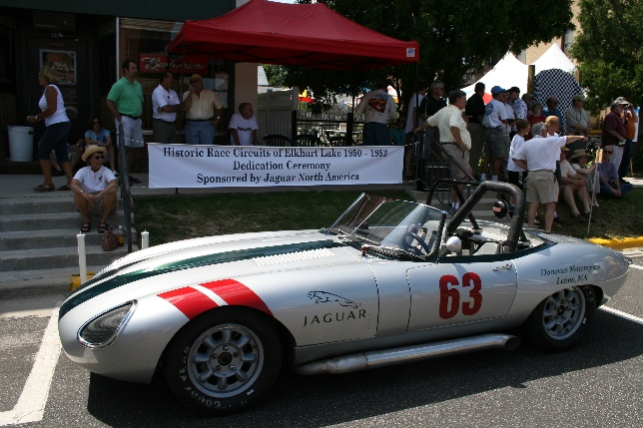

Jaguar XKE in racing trim on display provided by Jaguar of North America
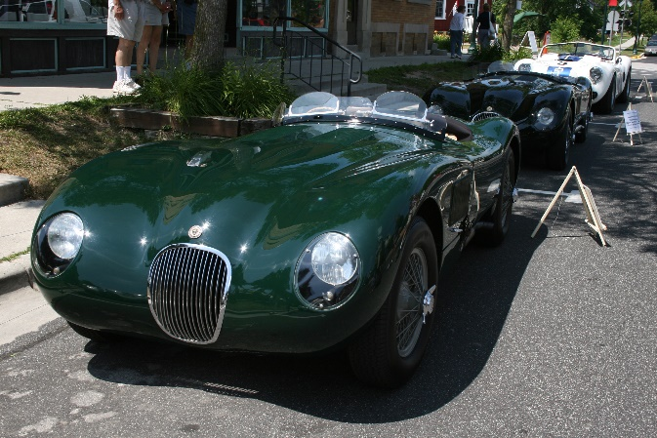
The Dedication Ceremony was held in the Village in front of the newly erected State Historical Marker (draped for the occasion) on Thursday, July 13, 2006. The event was nearly as memorable as the original races themselves. Lake Street was closed to normal traffic and participating sports cars lined the street from Rhine Street to Elm. A search for the original cars’ that raced and won events in 1951 and 1952 resulted in commitments from the cars owners to make the cars a part of the ceremony. Tom Mittler brought his Cunningham CR2 that had been driven to victory in the 1951 main event by John Fitch. Gerald Nell brought his C-type Jaguar that Phil Hill had driven to first place in the 1952 Sheldon Cup race, setting the course record. The Collier Collection brought its Cunningham CR4 in which John Fitch won the main event Elkhart Cup Race in 1952.
The C-type Jaguar driven to victory by Phil Hill in the 1952 Sheldon Cup Race on display courtesy of Gerald Nell.
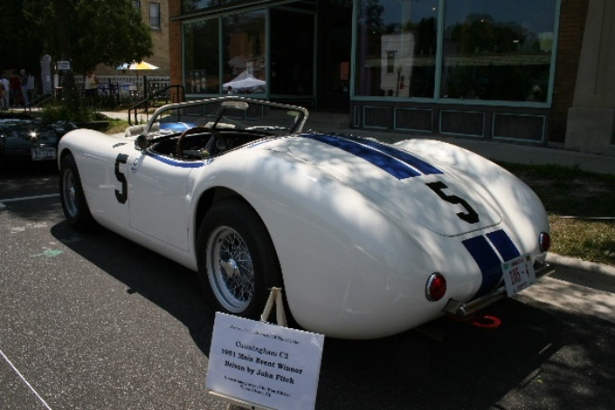
The Cunningham CR2 driven to victory by John Fitch in the 1951 Main Event on display courtesy of Tom Mittler.

The Cunningham CR4 driven to victory in the 1952 Elkhart Cup Race by John Fitch on display courtesy of the Collier Collection

The ceremony began with a police guided “Tour of the Circuits.” In all, eighty-two classic and vintage sports cars participated in the tour. For the occasion the Osthoff Walkway was reopened to vehicular traffic by special permission of the Osthoff and the Village of Elkhart Lake. The walkway, a section of Lake Street and part of the original race circuit approximately a quarter mile in length, had been closed to vehicle traffic when the new Osthoff resort was built. For the first time in years, Cunninghams, Jaguars, Allards, MGs, Porsches, and Ferraris streamed across the original circuit route in a spectacular display of automotive history.
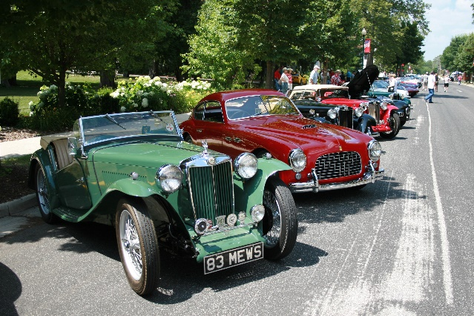

The Cunningham CR4 and John Fitch leads the "Tour of the Circuit" parade across the Osthoff Walkway.
Some of the vintage cars lined up on Lake Street prior to the start of the Tour of the Circuits
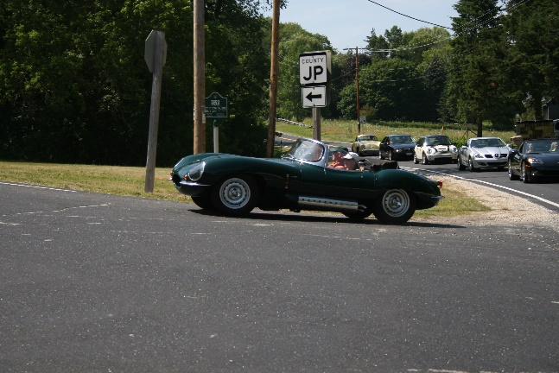
A D-type Jaguar turns onto the 1950 circuit at Ted's Turn as other Tour participants prepare to follow.
An MG-TD leads an Allard L-type Tourer across the Osthoff Walkway.
After touring both the 1950 and the 1951-52 circuits, passing all of the named location markers, the cars returned to Lake Street for the dedication and unveiling of the State Historical Marker by “Honored Guest” Phil Hill, John Fitch and Augie Pabst. The ceremony was opened by State Senator Joe Liebham and Jim Draeger, Architectural Historian for the Wisconsin State Historical Society, addressing the importance of historical preservation. They were followed by Jim Dentici speaking for the Milwaukee Region of the Sports Car Club of America.
John Fitch
John Fitch
Phil Hill
Augie Pabst

Then it was time for the “Honored Guests”. Augie Pabst paid tribute to the Historic Elkhart Lake Races without which Road America might never have existed. Phil Hill. although in failing health and speaking quietly, recalled his remembrances of racing in Elkhart Lake. You could have heard a pin drop during his comments. Here was a World Formula One Champion back in Elkhart Lake sharing his memories of racing here and his love for the area. The crowd loved it! John Fitch, who won twice in Elkhart Lake for the Briggs Cunningham Team, was both funny and poignant with tales of racing in the early days. His favorite memory of racing at Elkhart Lake: “It was very, very dangerous.” Wisconsin native and former USAC and SCCA champion Augie Pabst then asked Phil and John to join him in unveiling the State Marker.
Phil Hill
Augie Pabst

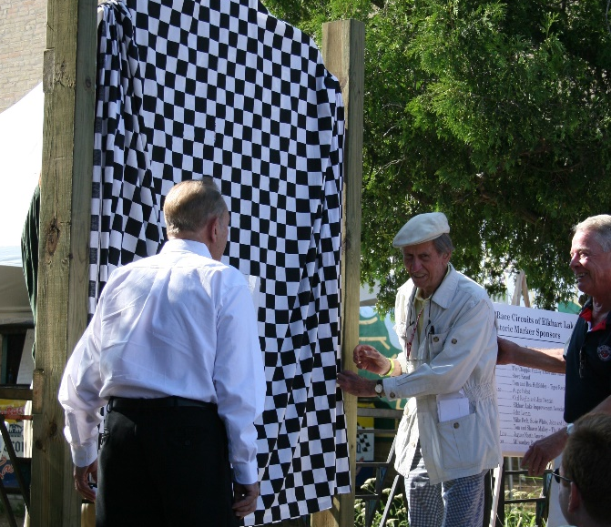

Phil John and Augie in front of the to be unveiled State Historic Marker.

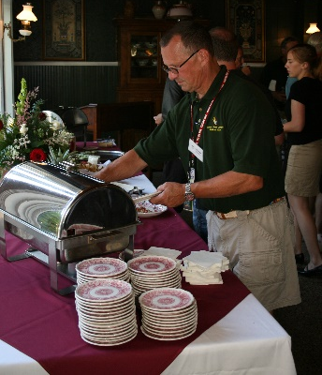
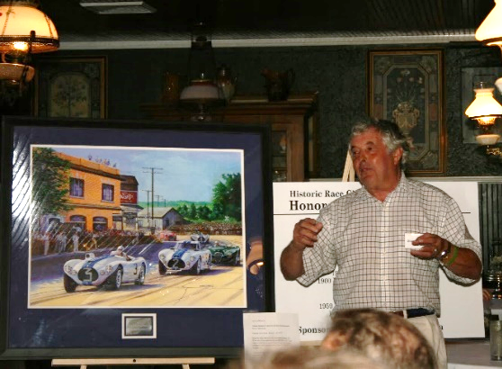
Following the ceremony, a private reception for marker donors, display car owners and honored guests was held at Siebkens Resort. Well known race driver, Brian Redman acted as master of ceremonies. To commemorate the dedication, HRC had commissioned an original painting by famed automotive artist Hector Cademartori. The original painting, “The Last Race”, was auctioned at the reception bringing in $5,000 to help the funding of HRC’s ongoing preservation efforts.
Brian Redman auctions "The Last Race" painting by Hector Cademartori at the dedication dinner event.
To conclude the Ceremony food and drink were shared by all and everyone agreed that it had been indeed….
HRC Co-founder Mark Pfaller at the buffet table.
a truly memorable DAY

